**Worksheet BST**

1. Insert the following keys into BST: A S E R C H I (Show the state of the tree after each iteration)
2. Given two values k1 and k2 (where k1 < k2) and a root pointer to the following Binary Search Tree, printBST() function prints all the keys of tree in range k1 to k2. For example given k1=1 and k2=3 the output is 2,1,3

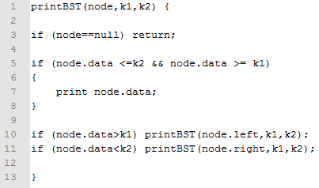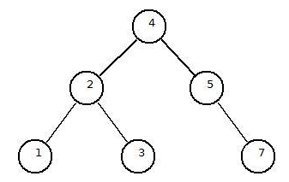

1. what is the output for k1=2 and k2=8?
2. what is the output for k1=5 and k2=15?
3. Fill in the following table, using Big-O notation to give the worst-case times for each of the data structure methods:

|  |  |  |  |
| --- | --- | --- | --- |
|  | Search | Insertion | Deletion |
| Unbalanced Binary Search Tree |  |  |  |
| Red-Black Tree |  |  |  |
|  |  |  |  |

1. Examine the following trees, do they meet the criteria for binary search trees? If one does not, explain why?

a.  5     
   / \   
  2   7

b. 5     
    / \   
  6   7 

c.   5    
    / \   
   2   7   
  /   
  1

d.   5    
    / \   
   2    7   
  / \   
  1   6

5. Given a sorted array, write a function that converts to a balanced BST.